How the H&G All-Time Index v2.0.0 is built, and how far you should trust it
A reproducibility appendix and methods record for the Honour and Glory All-Time Index, version 2.0.0.
This paper documents the shipped v2.0.0 public model. It is written for a reader who wants to know not only what the ranking says, but how it was produced, where it is firm, and where it is deliberately cautious. The headline claim of v2.0.0 is narrow and testable: the rating fit is fully deterministic, and two independent cold rebuilds of the published pipeline produce a byte-identical board. That property, not any single placement, is what the version is for.

What v2.0.0 is
The All-Time Index orders the public top 1000 men's professional boxers on a fixed 0 to 100 scale. Underneath the display index sits a six-dimension model fitted from a Whole-History Rating of the recorded bout corpus, followed by a documented Bayesian shrinkage prior. v2.0.0 keeps the v1.2 common-scale model, its validation suite, the Peak-form Elo posterior bands and the Data Confidence labels. It changes one thing in the fit and inherits a run of corrections accumulated since v1.2.3.
The board is score-neutral and rank-neutral against v1.2.3. No fighter changes position. The model scores are unchanged to rounding. The recomputed Peak-form Elo shifts by about half an Elo point on average across the field. The point of the release is reproducibility, and the rankings staying still under that change is a result worth stating plainly: making the fit deterministic did not move the order.

The change at the centre: determinism through bout-merge order independence (#47)
Version 1 of the rating engine resolved repeated or near-duplicate bout records with a merge step whose result depended on processing order. The fit was then pinned to a single sealed draw so that the published board would not drift between runs. The pin held the output still, but it concealed a real property of the method: re-run from scratch, the underlying fit could land somewhere slightly different.
v2.0.0 replaces that step (internally tracked as change #47) with an order-independent, quality-based bout merge. Given the same corpus, the merged bout graph is now the same regardless of the order records arrive in, so the Whole-History Rating that follows is the same, and so is everything derived from it. The pin is gone because it is no longer needed.
The test of that claim is direct. Build the board cold, from the committed inputs, twice, on the shipped pipeline. Then compare.
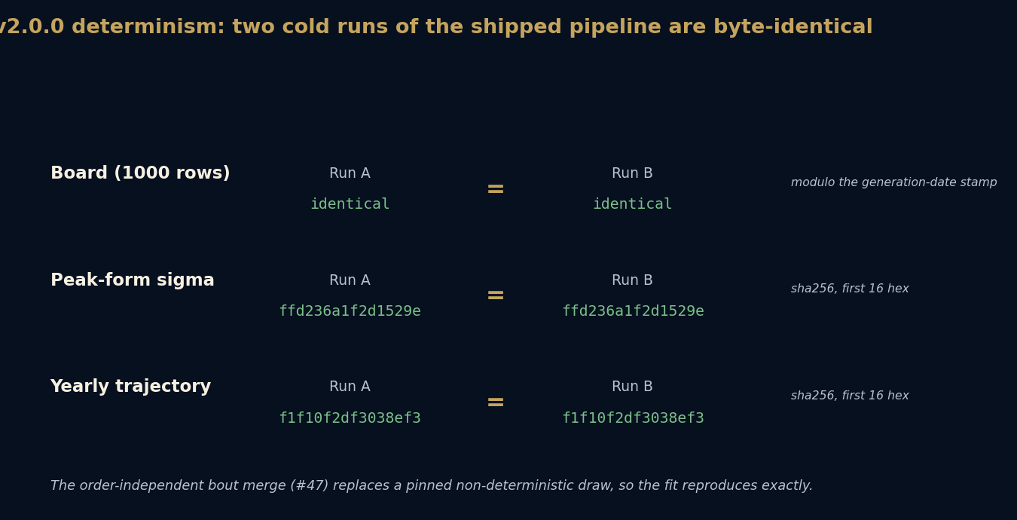
Two cold runs of the shipped pipeline are byte-identical: board, sigma and trajectory
The board is identical once the wall-clock generation stamp is set aside. The Peak-form sigma file and the yearly rating trajectory are byte-identical at the level of their SHA-256 digests. This is the scientific content of the release. A ranking you cannot reproduce is an opinion with a number attached. A ranking that rebuilds to the same bytes is a measurement, open to audit.

The reproducibility claim, stated precisely
It is easy to overclaim reproducibility, so the claim here is deliberately bounded.
The Python pipeline is self-contained except for the system Python interpreter and its standard library. The board, the sigma file, the yearly trajectory, and the rendered ranking pages are byte-identical across two cold runs. The render's self-containment is inferred rather than separately traced: the render reads inputs that live inside the pack, and it was shown to be deterministic by rebuilding it, not by tracing every file it opens. The board is reproducible from the pack given a compatible Python environment.
What this paper does not claim: that the entire website reproduces, or that the build is fully hermetic. The claim is the board and its pages, given compatible Python. That boundary is the point of stating it.

How the model earned trust: the audit cycle
The model was not declared correct. It was put through repeated adversarial audit rounds and revised where it failed.
The data-integrity round checked that the corpus the model reads matches a pinned fingerprint before any fit runs, so a drifted input cannot quietly change the board. The identity-resolution round hunted a class of six defect types in which one fighter can be split across transliterations or near-duplicate records, or two fighters merged by a shared name. The title-billing round examined where pre-1962 "world" billing had been credited as a modern undisputed or lineal title, and gated that credit on a reign reference rather than on the billing word. A membership round interrogated which fighters belong in the public 1000 at all.
Each round left a guard behind, so the same defect cannot return unnoticed. The board you read is the board that survived those rounds, which is a different and stronger statement than the board we believe is right.

Active years as a first-class quantity
Many era-relative measures depend on when a fighter was active, and careless year handling distorts them. v2 treats the active-year span as a quantity to be derived, not assumed. First and last active years are taken from the merged bout records, and a span correction was applied across the field where the previous handling had been loose. Getting this right matters because the model conditions evidence weight on era and on how recently a career ended, so a wrong span feeds a wrong confidence.

The colour line, recognised and handled with care
A history of the sport that ignored the colour line would be dishonest, and one that scored across it without comment would be careless. The data carries an explicit colour-line recognition layer with curated provenance. It neither erases the segregation-era barrier nor treats a missing cross-line bout as if it were a settled comparison. Where the record is shaped by who a fighter was permitted to face, the system states the pattern and stops there. It does not convert a historical barrier into a rating adjustment, and it does not impute motive to individuals from an absence of bouts.

The expert prior, stated modestly
The model includes a Bayesian shrinkage prior. It is worth being exact about what that prior is, because it would be easy to dress it up.
The prior is the International Boxing Research Organisation 2019 all-time pound-for-pound ranking. It is one organisation's list. It is not an averaged consensus of expert panels, and this paper does not present it as one. Its influence is bounded by construction: it is worth four equivalent evidence units, which means it shrinks a fighter's score towards the consensus position only as far as four bouts' worth of evidence would, and far less once a real career of recorded bouts is present. Ring, the Transnational Boxing Rankings Board and ESPN lists are held as comparators for validation, not blended into the prior.
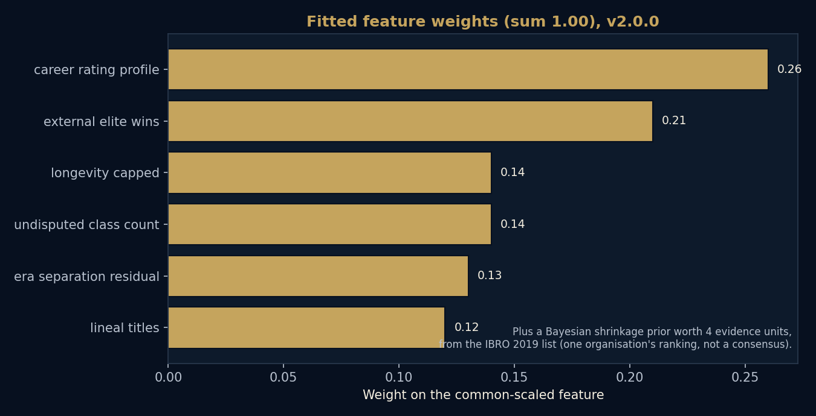
Fitted feature weights sum to one; the prior adds a bounded shrinkage on top
The six fitted weights sit on common-scaled features so the weights operate on comparable variance. Career rating profile carries the most weight, then external elite wins, then the title and longevity dimensions. The prior is an added scoring transform on top of these, not a seventh knob.

The two scales, and why the top peak is not number one
A frequent confusion is worth heading off. The 0 to 100 All-Time Index that orders the board is not the same as the Peak-form Elo rating shown on the rating curve. They measure different things and they are on different scales.
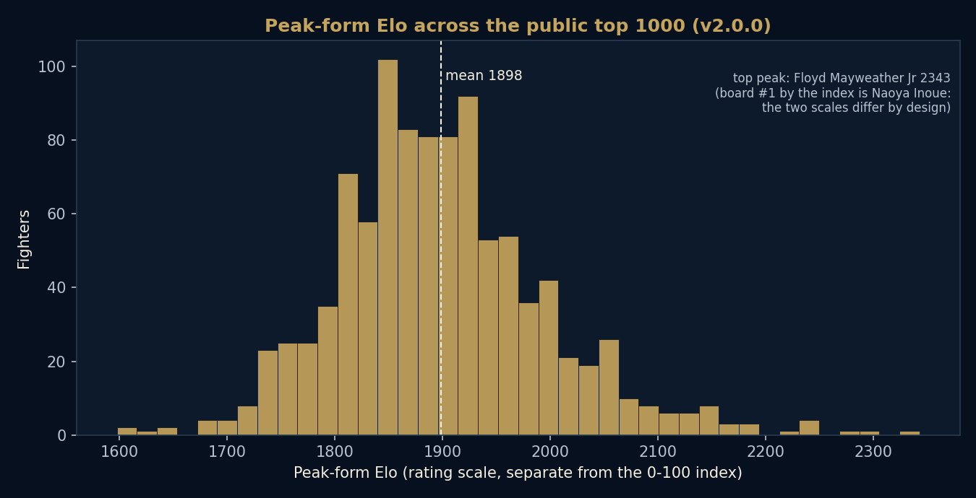
Peak-form Elo across the public top 1000
The highest Peak-form Elo in the field belongs to Floyd Mayweather Jr. The board's number one by the index is Naoya Inoue. Both statements are correct at once, because peak rating height and all-time index position are answering different questions. The dissertation states this rather than hiding it, because a reader who spots the mismatch and is not told why will reasonably lose trust.

Coverage, and the censoring it really shows
Older and thinner records carry more uncertainty, and the model needs a measure of how complete the evidence is for each fighter. Coverage is defined as the share of a fighter's known opponent bouts that the corpus has actually captured, computed from committed counts.
An earlier draft of this paper read coverage as a flat value near 0.75 for almost everyone and discussed it as a censoring artefact. That was a bug in the input, not a fact about the sport. The corrected coverage is a real gradient.
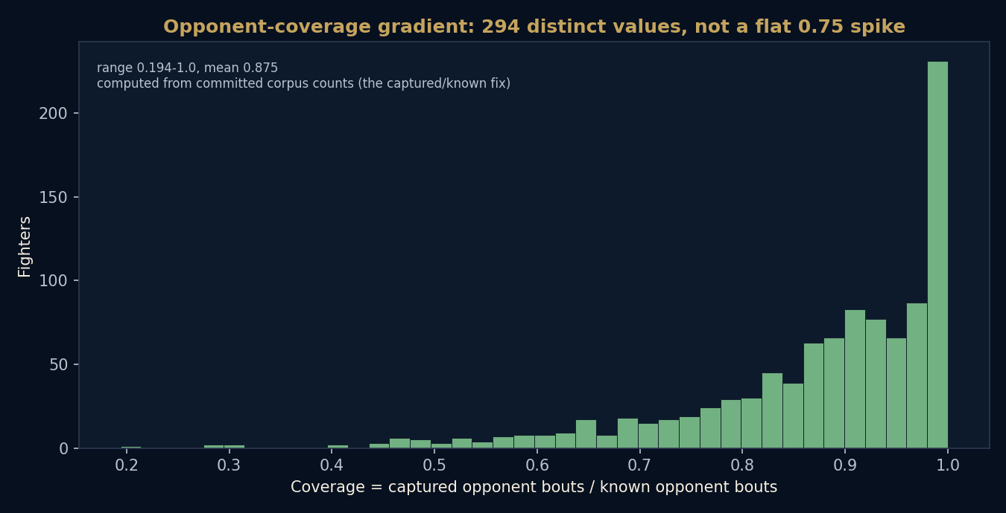
Opponent-coverage gradient: 294 distinct values, not a flat spike
Across the public 1000 there are 294 distinct coverage values, running from about 0.19 to 1.0 with a mean near 0.875. Fully captured careers sit at 1.0; thinner records trail down the gradient. This is the figure the coverage discussion is built on, and it is the reason Data Confidence is lower for some early-era and resume-heavy cases. The model rates those cases conservatively and says so on the page, rather than adding an era-strength correction that would require an editorial judgement the data cannot support.

The honest trade-offs
Three costs are accepted openly. None is hidden in a footnote.
First, the determinism trade. The order-independent fit costs about 0.7 per cent of stage-1 calibration measured by log loss. The stage-1 self-validity gate therefore fails, returning a non-zero code, and that failure is accepted explicitly by a documented flag rather than silently swallowed. The release buys reproducibility and pays a small, stated amount of calibration for it.
Second, divisions are post-patched, not root-computed. v2 reproduces the live divisions by applying a committed correction inside the pipeline, exactly as the live site does. It does not compute each fighter's division cleanly from an era-aware weight-class derivation. That root-cause computation is deferred to a later release, and this paper does not imply the clean version exists yet.
Third, two joins were re-keyed for robustness. The sigma-prior join and the enrichment join were moved from matching on a display slug to matching on a stable fighter identifier, which is the correct key. These corrections are neutral against the live board, so they change no placement, but they are the right engineering and they remove a class of silent mismatch.

What a careful reader should take away
v2.0.0 is a major release because it makes the rating fit fully deterministic and folds in the corrections gathered since v1.2.3, while leaving the published order neutral against v1.2.3. You can rebuild the board and check it. The placements near the top are firm; close ranks in thin-record regions should be read with the Data Confidence label beside them. The prior is one list, bounded in influence. The divisions are correct on the page but not yet computed from first principles. None of that is a reason to distrust the ranking. It is the set of conditions under which the ranking means what it says.
A formal version of this paper is available to download, and a plain-language companion explains the same ideas without the apparatus.

